Corporate Database Creation with UI

Create the Database
The first step is creating the corporation database. I purposely decided to use all lower case for the database (this is a common convention).
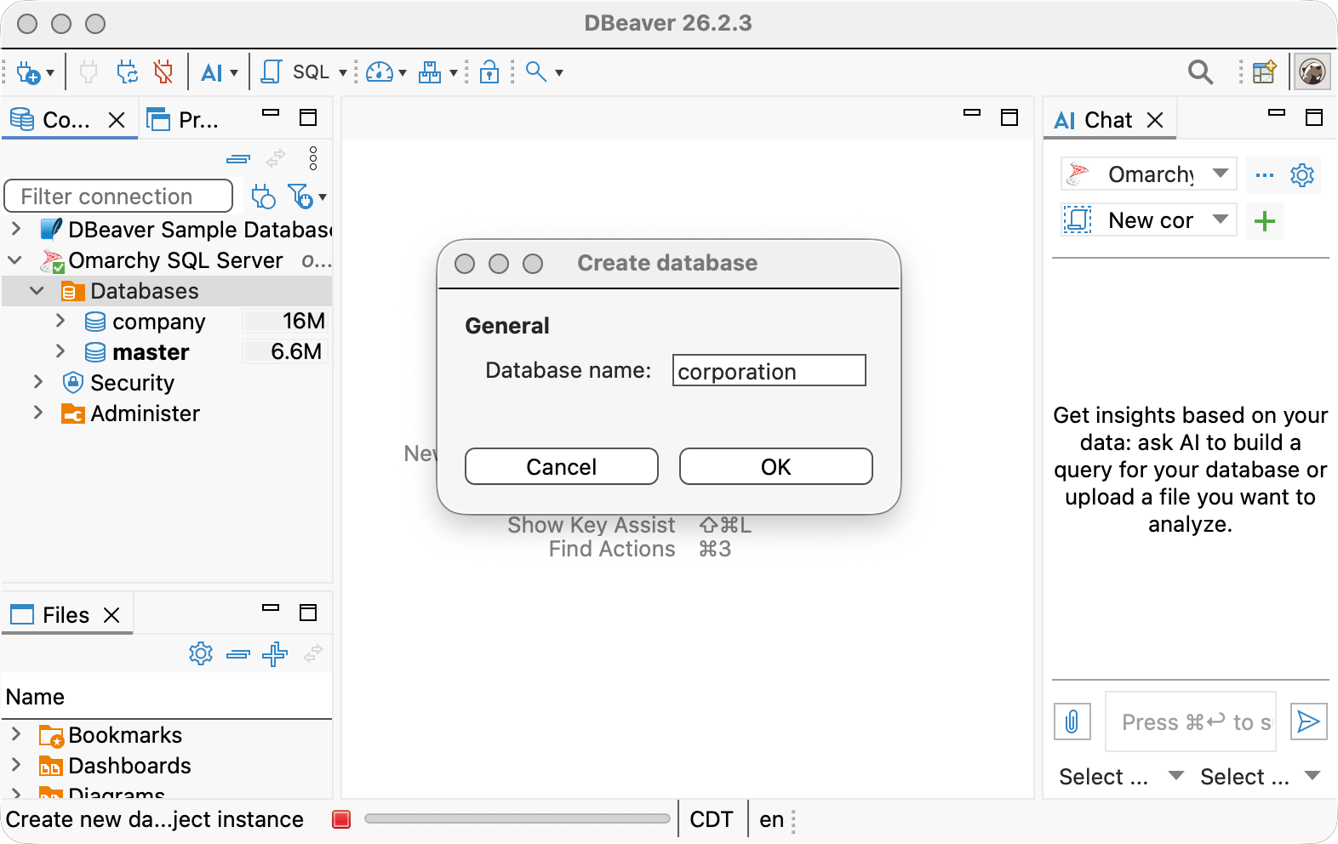
Figure 1: Creating the corporation Database

Create the Tables

Department Table
Create the Department table first. The other tables both have foreign keys to Department so I want to create that one first. If we create the Employee or Job table first, we’d have to go back and add the foreign key later once the Department table was created.
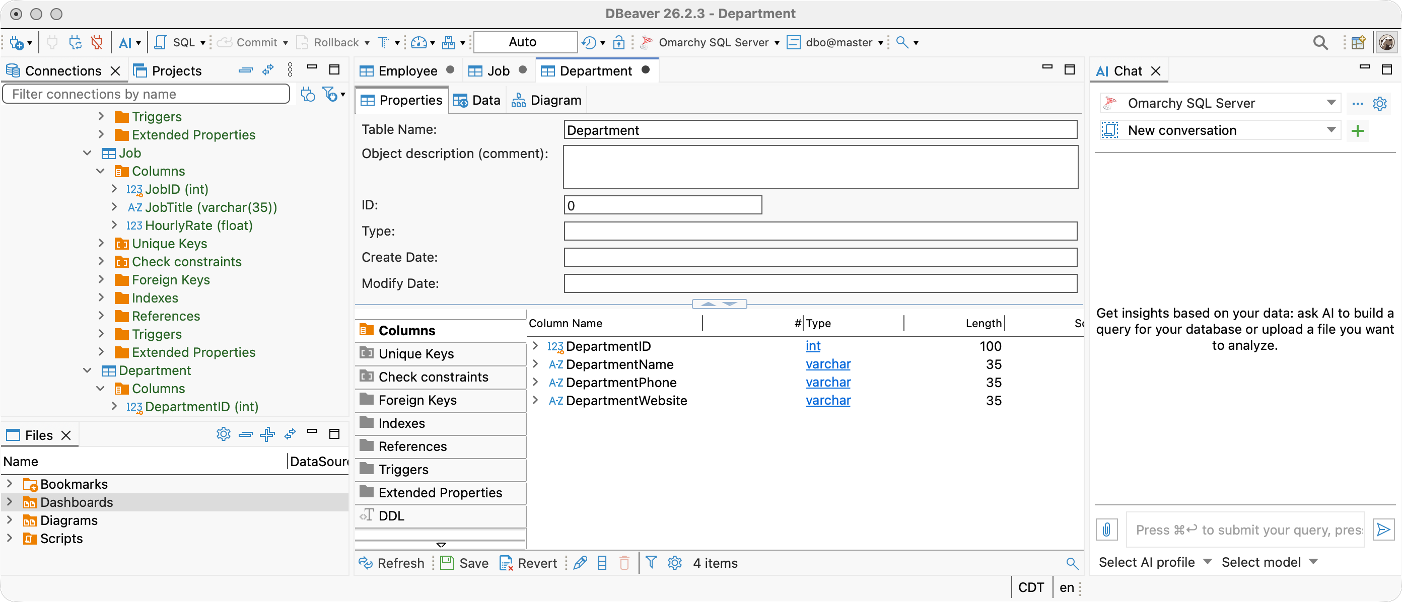
Figure 2: Create Department Table

Job Table
For the same reason as above, we want to create the Job table before the Employee table.
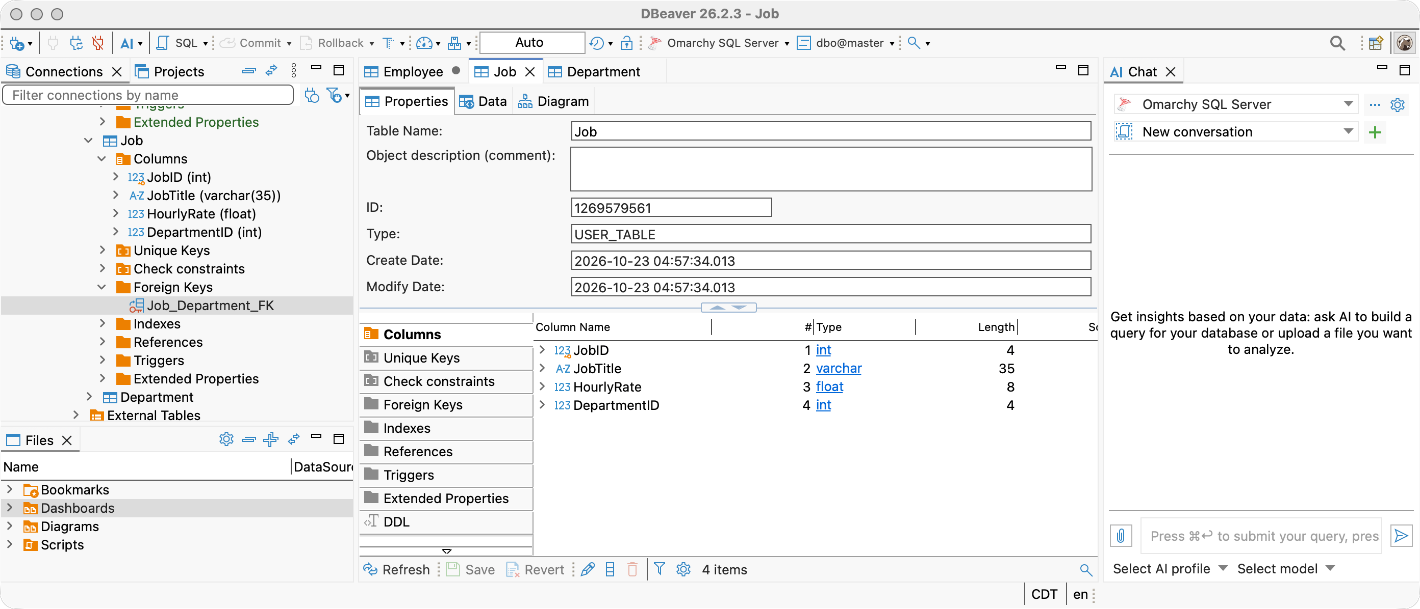
Figure 3: Create Job Table

Employee Table
Create the Employee table.
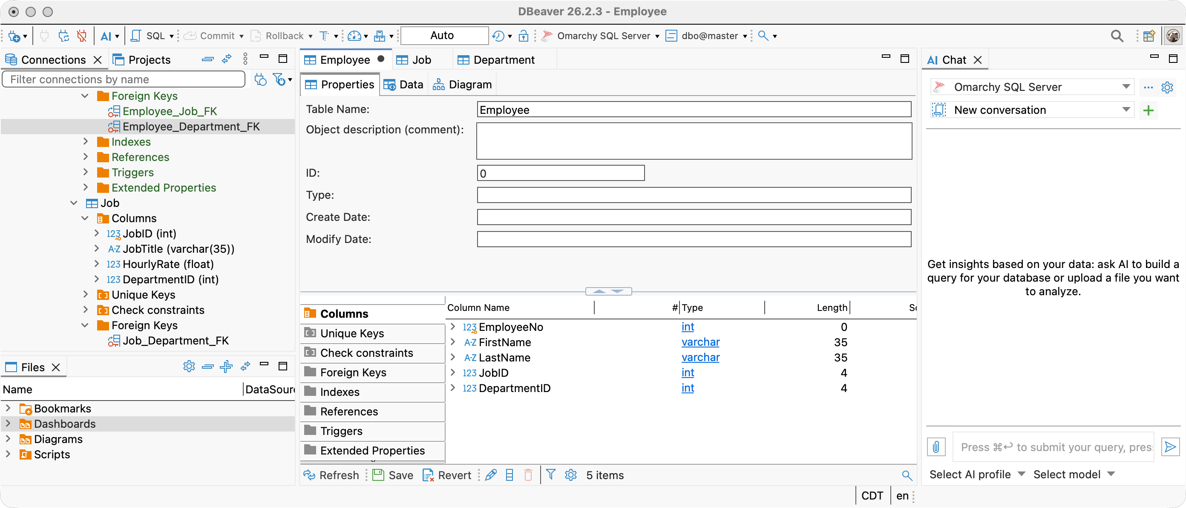
Figure 4: Create the Employee Table

Insert Data
Insert data in the respective tables. Use the same order as table creation as you can’t create a record with a foreign key to a record that does not yet exist. Restated, an Employee record can’t reference a Job that does not yet exist.
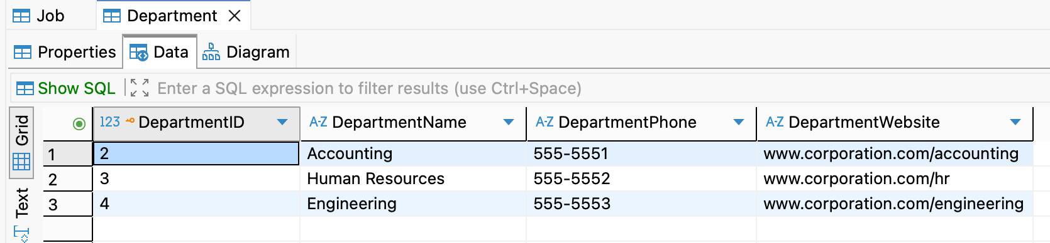
Figure 5: Create the Department Records
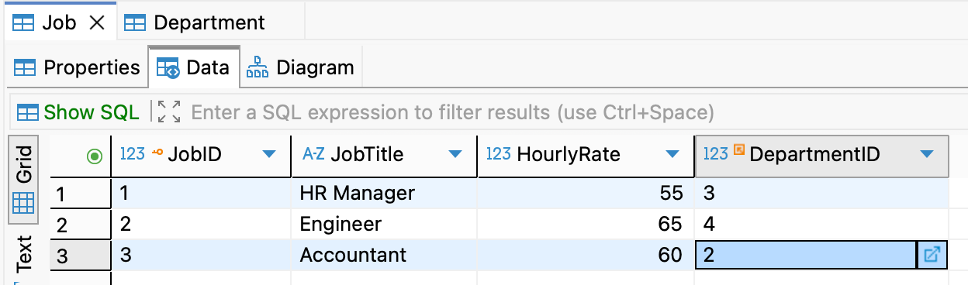
Figure 6: Create the Job Records
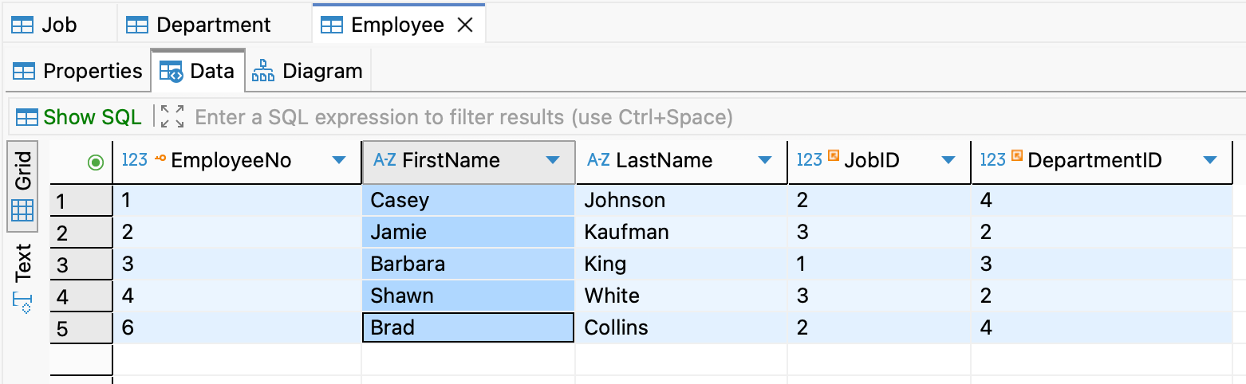
Figure 7: Create the Employee Records

